Effectiveness of distance based suicide interventions, a multi-level meta-analysis and systematic review.

Jim Schmeckenbecher1, Katrin Rattner2, Robert J. Cramer3, Paul L. Plener4, Anna Baran5, & Nestor D. Kapusta1

1 Department of Psychoanalysis and Psychotherapy, Medical University Vienna, Austria

2 kbo-Inn-Salzach-Clinic Freilassing, Germany

3 Department of Public Health Sciences, University of North Carolina at Charlotte, USA

4 Department of Child and Adolescent Psychiatry, Medical University Vienna, Austria & Department of Child and Adolescent Psychiatry and Psychotherapy, University of Ulm, Germany

5 Department of Medicine and Optometry, Faculty of Health and Life Sciences, Linnaeus University, Kalmar & Department of Psychiatry, Blekinge Hospital, Karlshamn, Schweden

Author note

Correspondence concerning this article should be addressed to Nestor D. Kapusta, Medical University Vienna, Department of Psychoanalysis and Psychotherapy, Waehringer Guertel 18-20, 1090 Wien. E-mail: [nestor.kapusta@meduniwien.ac.at](mailto:nestor.kapusta@meduniwien.ac.at)

Abstract

Background: Distance Based Interventions (DBI) to reduce suicidal thoughts and behaviours are increasingly relevant. They are more affordable, scalable and available than traditional face-to-face interventions, helping to narrow the gap between needed and provided care. Aim: Evaluating the overall effectiveness of DBI against suicidal thoughts and behaviours. Methods: We systematically searched Web of Science, Scopus and Pubmed for all DBIs primarily aimed at reducing suicidal thoughts and behaviours. Data was analyssd using a using multilevel meta-analysis with robust variance estimation. Results: In total 40 studies were found, reporting 110 outcomes. DBI effectiveness in reducing suicidal thoughts was low (SMD = -0.17 CI95%[-0.24; -0.11]) but signficant. DBIs against suicidal behaviours DBIs were also effective (SMD= -0.06 CI95%[-0.09; -0.03]). Human involment in DBIs had no significant impact on effectiveness. Conclusion: DBIs maybe an effective tool in a stepped care approach, especially for reducing suicidal thoughts. Future research should focus on the development of mass distributable autonomous programs against suicidal ideation and plans.

*Keywords:* suicide, suicide prevention, meta-analysis, distance based intervention, remote intervention, e-based intervention

*Word count:* 3500

Effectiveness of distance based suicide interventions, a multi-level meta-analysis and systematic review.

# 1 Introduction

Suicidal thoughts and behaviours are both a challenge for public health and for service providers, given that annually 138 million people experience suicide ideation, 20.7 million people attempt suicide [1] and around 700,000 people die by suicide [2]. Still only 17% to 56% of persons experiencing suicidal thoughts and behaviours receive treatment [3]. Besides these unadressed needs, low treatment rates are linked to two structural barriers: Treatment cost and availability [3].

Improving affordability and accessibility of treatment means to provide suicide-specific care in terms of tailored interventions according to the patient’s stage of suicidal progression (e.g., pre-motivation, ideation only, plan/attempt; [4]), rather than using a one fits all solution. It has been suggested to implement a stepped care approach: least restrictive care at early stages and to increase restrictions gradually with advancement of suicidal progression [5]. In this sense, easily available and affordable treatment can lower treatment barriers and include individuals otherwise hesitating to seek help at early suicidal stages [3]. Early interventions at the stage of suicide ideation, have been suggested to lower human suffering and to prevent future suicides [6].

Distance Based Interventions (DBI) are least restrictive treatments, in terms of local availability, affordability and available service hours. Under-serviced areas can be supported by both tele-health and apps. While in the short term the development and evaluation of Apps and tele-health interventions are expensive, in the long run they are less expensive and less resource-intensive than individual psychotherapy, especially when a large number of people are treated.

During the past two decades a number of randomized control trials examining DBI have been published. Starting at the turn of the millennium, with studies using phone-calls [7] and post-cards [8], leading to crisis hotlines and e-mail follow-ups [9]. Recently the field has expanded to online programs [10,11] and since the Covid-19 outbreak increasingly to tele-health approaches [12]. Several Meta-analyses have been published on subsets of DBI [13,14].

To give recommendations for future research and clinical practice, our meta-analysis differentiated between autonomous DBI (aDBI) (i.e. apps, online programs) and human DBI (hDBI) (phone calls, postcards, tele-health), which allows to investigate, whether the scalability of hDBI can be utilized without risking effectiveness. To reach as many suicidal individuals as possible in early stages of progression, distance based programs need to be scalable and cost-effective. aDBI have superior scalability compared to hDBI [15], as they are less expensive per single intervention, less restricted by available service hours, more translatable, and immediately available.

In order to draw practical conclusions we asked three questions, implemented as moderation analyses: (a) Whether DBI are effective against suicide ideation and/or against suicidal behaviours, (b) How stable these interventions are over time and (c) Whether effectiveness of such programs was independent from the chosen control groups (TAU/Attention Placebo/waitlist).

## 1.1 Methods

The systematic search followed the Preferred Reporting Items for Systematic Reviews and Meta-Analyses guidelines [16] and was Pre-Registered on Prospero under the pre-registration number: CRD42020218791.

Search strings were defined using repeated searches combining MeSH terms relating to suicide prevention OR intervention, with the intervention types, (e.g.) Letter, App, Web-based, OR distance. The resulting search string was tested and refined using two related meta-analyses, one on hDBI [13] and one on aDBI [14] (see Appendix for final strings).

Once search strings were established, the first one hundred search results of Web of Science were examined together by the authors J.S. and K.R., establishing a common degree of understanding. Afterwards, both authors independently searched Web of Science, Scopus and Pubmed; Systematic searches were last updated in December 2021. Cohen’s kappa between both authors was 0.806.

## 1.2 Inclusion and exclusion criteria

All peer reviewed randomized control trial studies were included, which investigated any form of DBI with at least one primary outcome being self-harming thoughts and/or behaviours, such as suicidal ideation, suicidal planning, suicide attempts, and suicide. Face-to-face meetings were allowed, if these were not part of the intervention - i.e. for informing, testing or screening purposes.

All suicidal thoughts and behaviour outcomes of applicable studies were coded, excluding combined outcome measures, such as the total score of Suicidal Behaviours Questionnaire-Revised (SBQ-R) which sums lifetime thoughts and behaviours in a total score.

## 1.3 Data Extraction and Coding

Data was coded independently by two authors (J.S and K.R.). Where possible non-imputed results, were coded. The following variables were extracted: Author, Year, control group of study, country of study, sample type, sample size, intervention type, sex ratio, mean age, mean age (*SD*), the outcome name (e.g. suicidal ideation), intervention duration in weeks, the participant attrition rate, the follow-up time, standard mean difference (*SMD)* and variance of *SMD*. In addition, all outcomes were coded for the moderation analysis into subgroups (see Table 1).

Outcome allocation to Moderator Analyses

|  |  |
| --- | --- |
| Moderator group | **Outcome Name** |
| Acts | Suicide, suicide attempts, self harming behaviours. |
| Thoughts | Suicidal thoughts, suicidal ideation, suicide plans. |
| Human involved | Phone calls, cognitive behavioural treatment, personalized letters or personalized e-mails. |
| Autonomous | Applications, websites, non-individualized letters or non-individualized e-mails. |
| TAU | TAU, enhanced TAU, intensive case monitoring, |
| Attention Placebo | Attention placebo, control article, journalling, attention control, control program, body positivity images. |
| waitlist | no contact, reminder letter at the end, waitlist, no interventions |

The authors compared the finalized coding sheets, discussed differences and re-coded affected studies until a unanimous result was achieved.

Risk of bias was assessed using the RoB-2 [17] and Trim and Fill was used as the publication bias detection [18,19].

## 1.4 Statistical Method

To incorporate all outcomes of interest we used a three level meta-analysis [20,21], with Robust variance estimation (RVE) [22,23]. RVE return valid confidence intervals in presence of dependent data [24]. While the three level model allowed for outcome-level heterogeneity investigation [25]. Models were fitted with restricted maximum likelihood estimation (REML), RVE correction was based on Pustejovsky and Tipton [26].

Calculations were done in R [27] using the package metafor for the three level model [28] and the package clubSandwich [29] for the RVE correction. All data needed for full reproducibility, as well as all deviations from the preregistered Report are publicly available on Github.[1]

## 1.5 Sensitivity Analysis and bias

Given that NSSI [30] and suicidal behaviours [31] differ qualitatively, we employed two sensitivity analyses: (a) Including Non-Suicidal Self-Injury (NSSI) as an outcome, (b) Excluding suicide deaths as an outcome.

Risk of bias was assessed using the RoB-2 [17] and Trim and Fill was used as the publication bias detection [18,19].

# 2 Results

We identified 2,213 papers in the databases (see Flow Chart), in the end 35 independent RCT trials were included in the analysis. The difference between included studies in the flow chart and reported independent RCT trials is explained by follow-up studies that use the same sample as their parent study. As these study pairs have the same sample we treated them as a single RCT. Further, one study included three statistically independent RCTs [11].

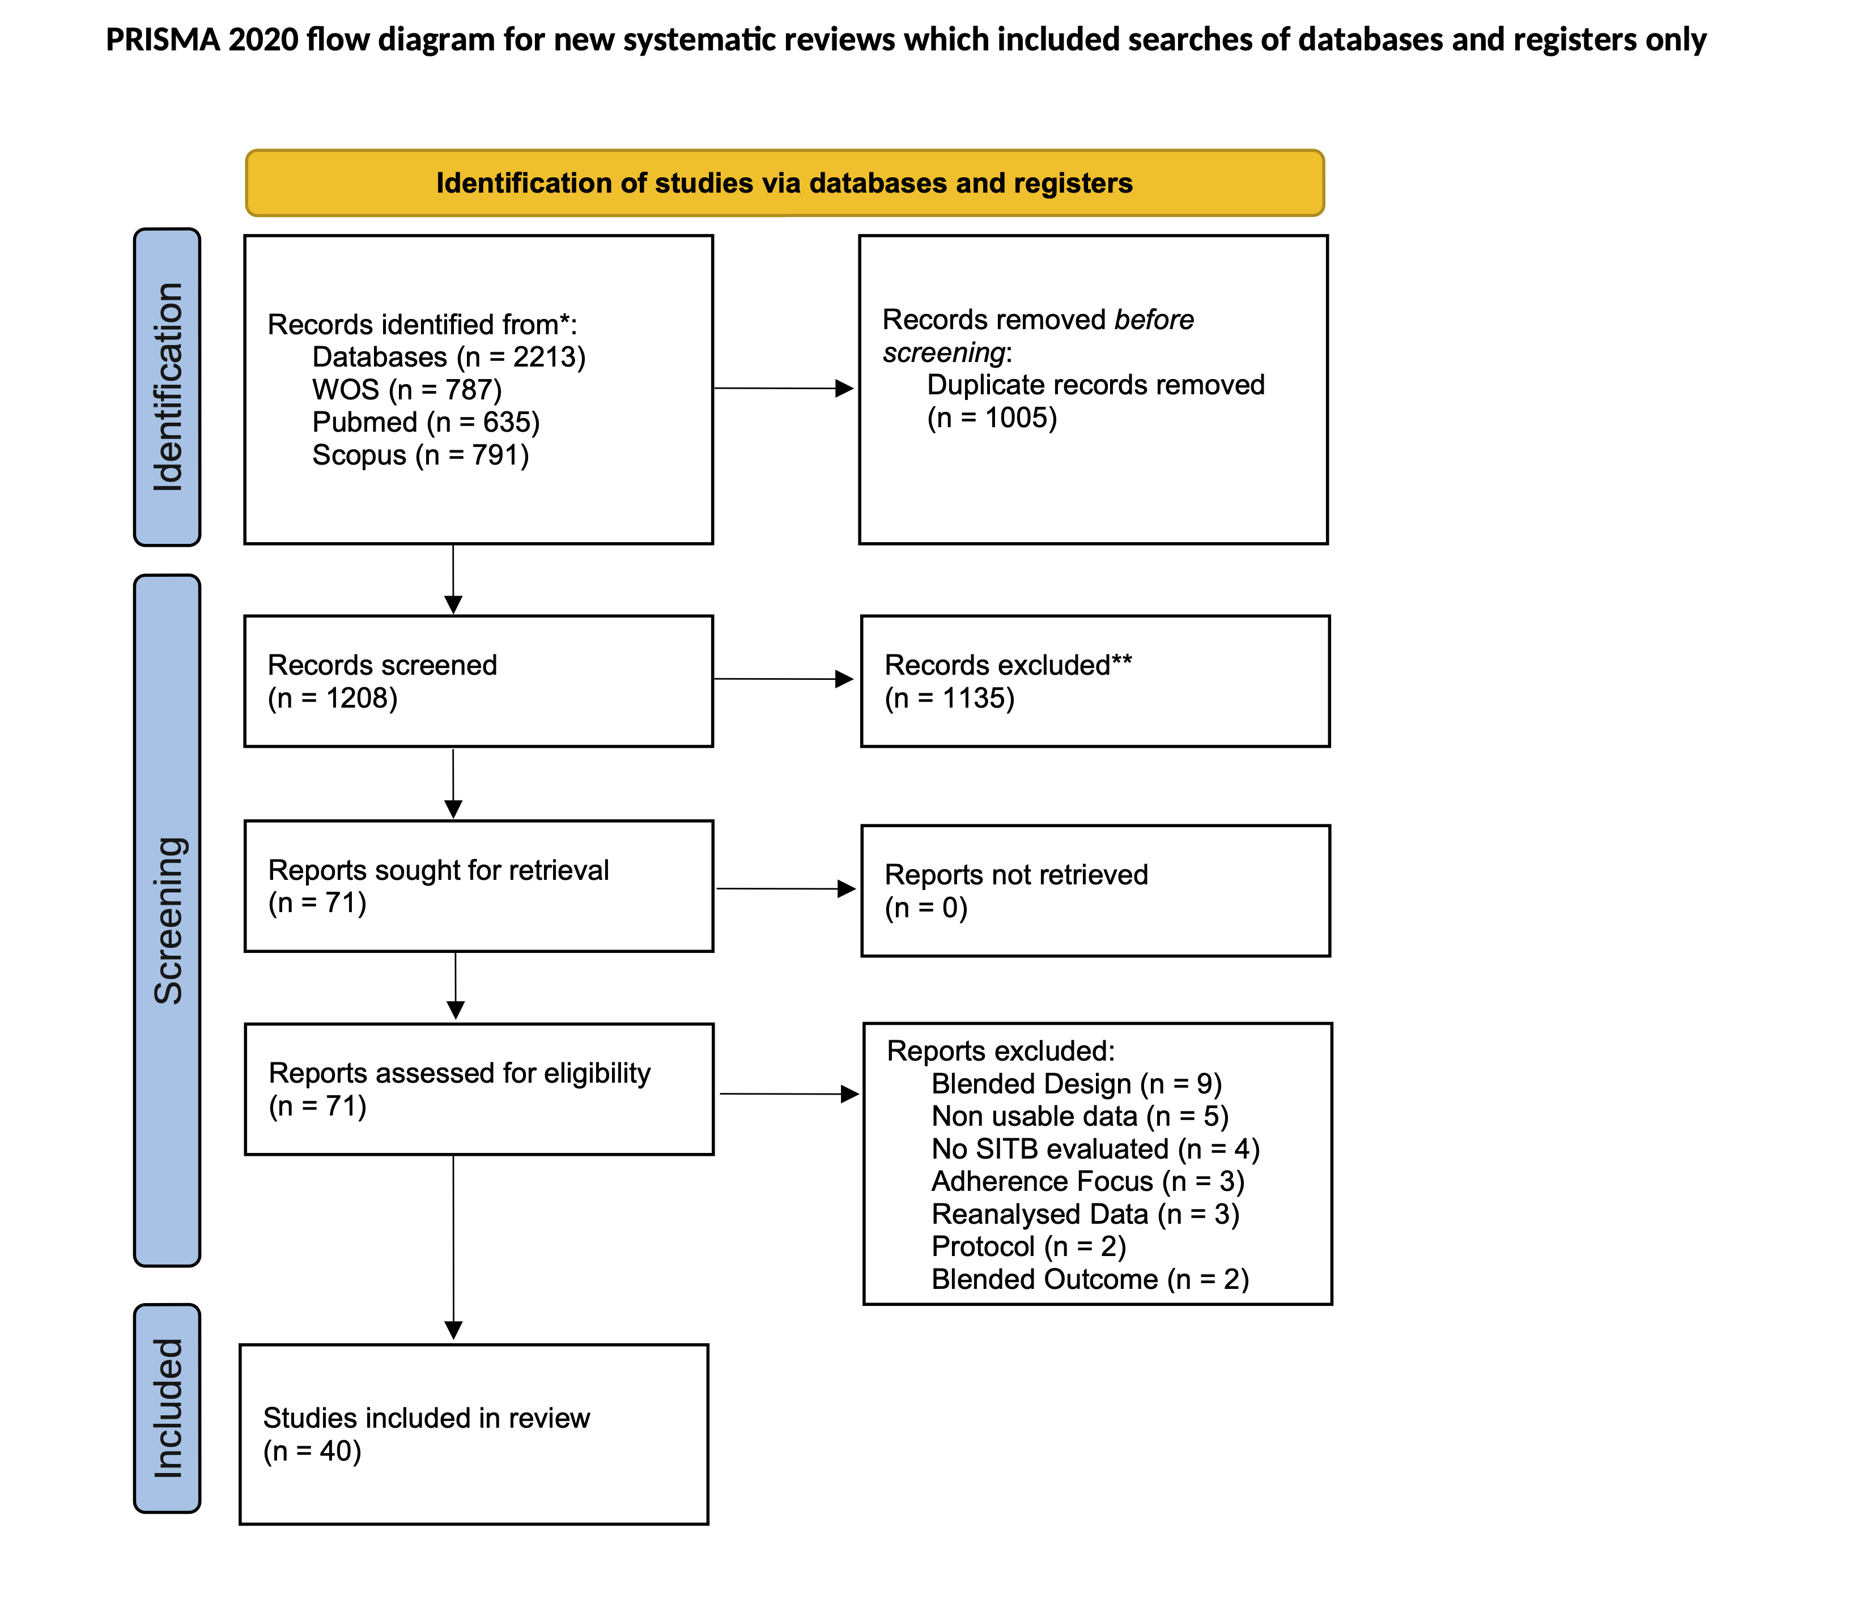

*Flow* *Chart* of all studies

Overall, 110 outcomes emerged, with 65 outcomes of the category thinking, predominantly ideation and planning, and 45 outcomes of the category acting, including studies examining mostly deliberate self-harm, self-harm and suicide attempts.

20 outcomes were found in the hDBI category and 90 outcomes were found for aDBI. The median duration of studies was 26.00 weeks, with a range of 0.14 to 782 weeks. The median time between post-intervention measures and follow-up measures was 17 weeks, with a range of 522 weeks to 0.86 weeks. Finally 52 outcomes were based on TAU group comparisons, 14 outcomes were based on waitlist control groups and 44 outcomes were based on attention placebo control groups.

The median attrition rate was 17.00% with a maximum of 64.50% and a minimum of 0%.

### 2.0.1 Sample Characteristics.

In total 11158 participants were included at post-intervention and 9201 at follow-up. Out of all participants, 64.43 % were female and on average 31.87 (*SD*= 10.01) years old. In studies the youngest reported mean sample age was 14.70 (*SD*= 1.46) years, the oldest mean sample age was 51.00 (SD= 11.39) years.

Out of a total of 35 studies, most data was retrieved from westernized educated industrialized democracies (WEIRD), predominantly the United States (*k=* 10), followed by Australia (*k* =9). From non-westernized educated industrialized democracies *5* studies emerged.

## 2.1 Main Analysis

DBI were effective in reducing suicidal thoughts and behaviours, standardized mean difference (SMD) = -0.12 CI95%[-0.17; -0.08]; Heterogeneity was significant at *Q* (df = 109)= 154.66, *p =* 0.00.

DBI are more effective against suicidal thoughts than suicidal behaviours (*SMD=* -0.12 CI95%[-0.18; -0.05]). The average effectiveness against suicidal thoughts was *SMD=* -0.17 CI95%[-0.24; -0.11], while suicidal behaviours was lower at around *SMD=* -0.06 CI95%[-0.09; -0.03]. Heterogeneity was non-significant *Q* (df = 108) = 118.46, *p =* 0.23. (See Figure 2)

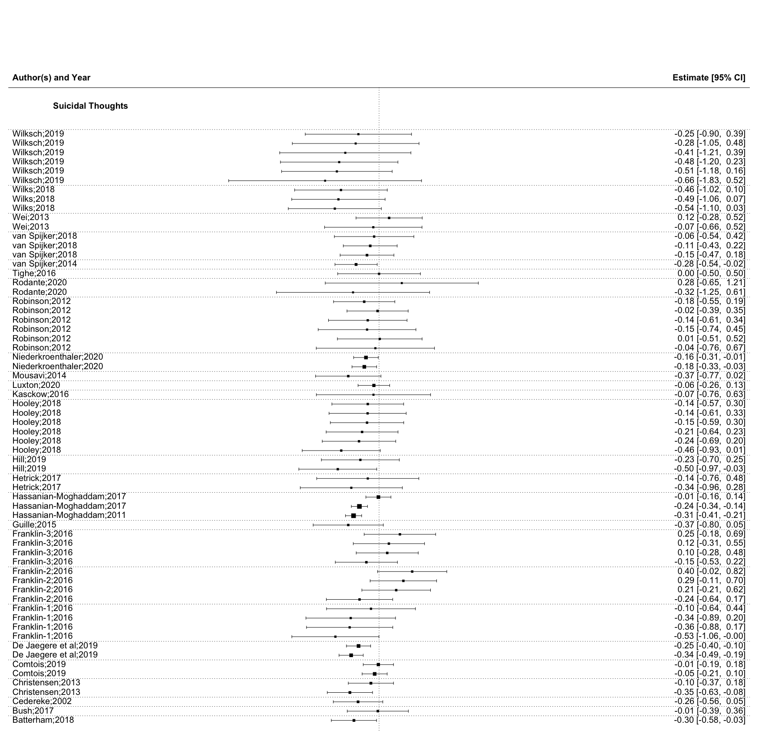

*Note:* *Dotted* Lines represent Study Level Dependencies

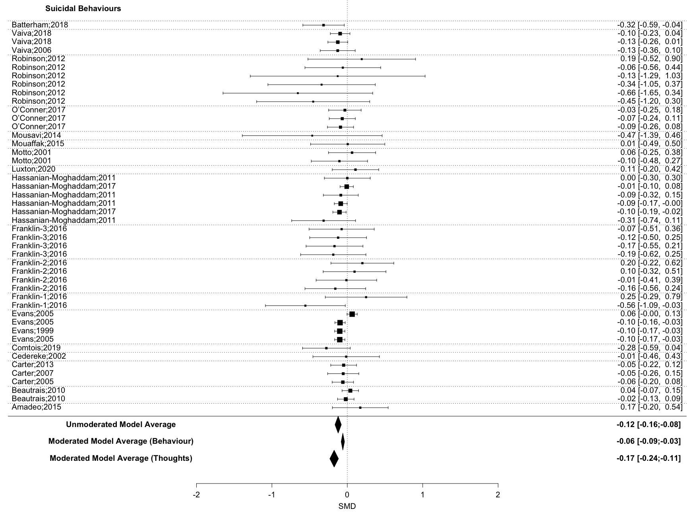

*Note:* *Dotted* Lines represent Study Level Dependencies

Due to the small number of studies using a waitlist condition, the comparison of waitlist and attention placebo groups were not trustworthy according to their profile likelihood plots [32].

Therefore, waitlist and attention placebo were combined into one control group and compared to TAU.

Comparing the combined control-group vs. TAU, showed that DBI given alongside TAU was significantly less effective against suicidal thoughts or behaviours (*SMD=* -0.17 CI95%[-0.27; -0.08]), than DBI given alongside a waitlist or attention placebo control group. Heterogeneity remained significant at *Q* (df = 108) = 139.80, *p =* 0.02.

Possible covariance of control-group type (i.e. TAU vs. watilist and attention placebo) and outcome type (i.e. thinking vs. acting) was investigated. As suicidal behaviours and suicidal thoughts were unevenly distributed between studies using different control-group types (see figure 2), an exploratory analysis including both moderators was implemented. When including both moderators, the difference between control groups became non-significant, with *SMD=* 0.04 CI95%[-0.06; 0.14], but suicidal acts and suicidal thoughts remained a significant moderator, with *SMD =* -0.10 CI95%[-0.19; -0.01] in favour of suicidal thoughts. Heterogeneity was not significant at *Q* (df = 107) = 118.04, *p =* 0.22.

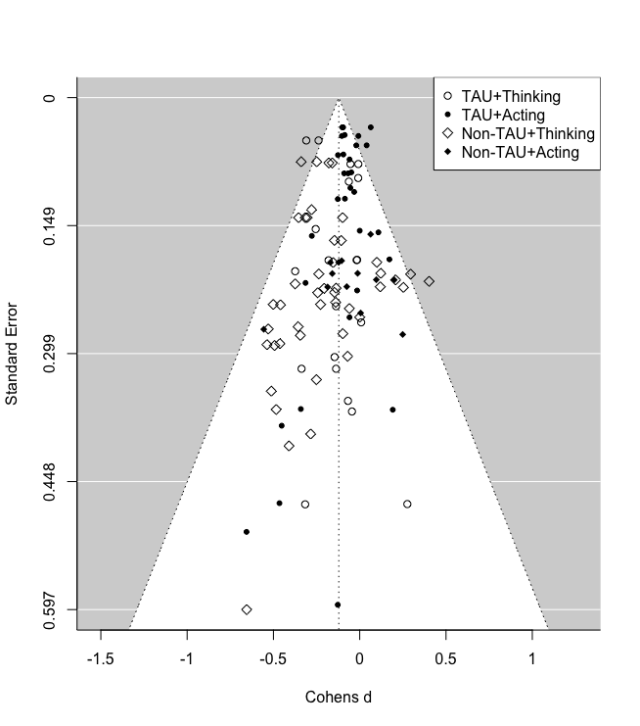

*Funnel* *Plot,* including all outcomes according to moderator type

Effectiveness of DBI decreased between time-points at *SMD =* 0.03 CI95%[-0.03; 0.08] non-significantly. Heterogeneity was significant at *Q* (df = 108) = 152.45, *p =* 0.00.

aDBI and hDBI did not differ significantly in effectiveness, *SMD=* -0.06 CI95%[-0.14; 0.02], heterogeneity was significant at *Q* (df = 108) = 147.09, *p =* 0.01.

## 2.2 Sensitivity Analysis and Bias

Both, inclusion of NSSI outcomes (*o* = 10) and exclusion of suicide death outcomes (*o* = 4) had negligible impacts on the subgroup of suicidal behaviour outcomes. The Inclusion of NSSI did not change the effectiveness of DBI, *SMD-NSSI*= -0.06 compared to *SMD+NSSI*= -0.06, and exclusion of suicide death outcomes did not change the effectiveness *SMD+suicide death* = -0.06 to *SMD-suicide death*= -0.06. It has to be noted that only Franklin et al. [11] reported NSSI measures in a study aimed at reducing suicidal behaviour and suicidal thoughts as a primary outcome.

Risk of bias of all *independent* studies was mixed (see Figure 3.). Using Trim and Fill, no publication bias could be observed.

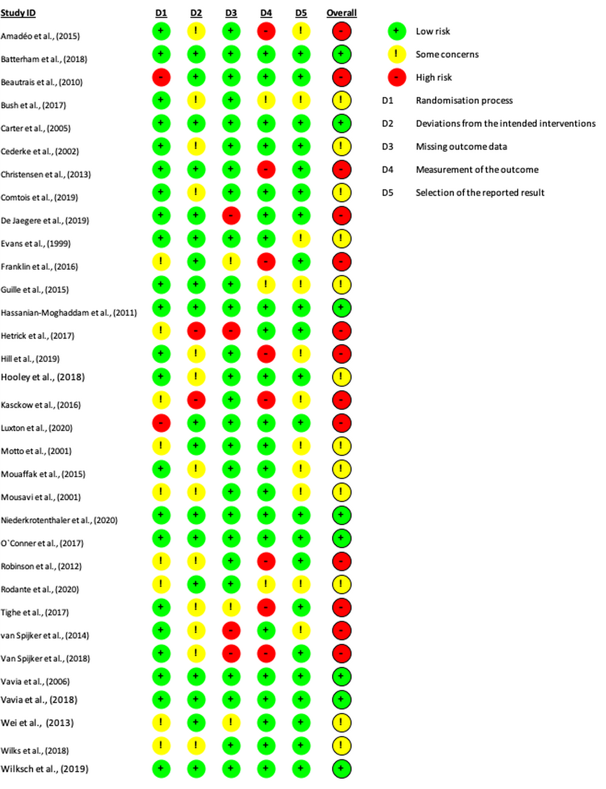

*Quality* *Assessment* of all independent studies

# 3 Discussion

In this meta-analysis, we examined the effectiveness of DBIs in reducing suicidal thoughts and behaviour. The quality of evidence was good, with a substantial number of high and medium quality studies and no observed publication bias. On average, DBI reduced both suicidal thoughts and suicidal behaviour.

### 3.0.1 Contextualizing results with other Meta-Analyses.

We contextualise our findings using meta-analyses of psychotherapeutic face-to-face interventions for suicidal ideation and/or behaviour. While it can be argued that such a comparison is biased, as each meta-analysis has different inclusion criteria, designs and underlying assumptions, it nevertheless offers a rough estimation of, which effect sizes can be expected from a suicide intervention. To maximize comparability we only include meta-analyses on psychotherapeutic face-to-face interventions that were RCT studies, using TAU, waitlist or attention-placebo control groups and were published in the last decade.

We searched Web of Science using the search term: ‘“suic*” AND “therap*” AND (meta-analys* OR meta analys*).’ Nine meta-analyses were found [33–41]. One [38] did not exclude particular populations or therapeutic approaches.

#### 3.0.1.1 Effectiveness of Distance Based Interventions (DBI) for suicidal behaviours.

We showed that DBI significantly reduced suicidal behaviours (*SMD*= -0.06 CI95%[-0.09; -0.03]). When comparing the results of our meta-analysis on DBI with the results of nine meta-analyses on face-to-face interventions, we found three meta-analyses with significantly higher results, while six meta-analyses reported non-significant differences. Two of the three meta-analyses reporting significantly higher results for DBI in comparison to ours, were comprised of adolescent samples [34,35]; these meta-analyses used ‘self harm’ as an outcome and showed significantly higher reductions by Dialectical Behavioural Therapy (DBT) at post-treatment [34,35], although their results were not significant after three months follow up [34]. In addition, one of these meta-analyses reported significantly stronger results in favour of eclectic therapy (ET) than we did for DBI; however ET led to a significant increase in ‘self-harm’ at three months follow-up [34]. The third meta-analysis reporting stronger results, in comparison to our results for DBI, included only psychoanalytic approaches [37] and used suicide attempts and ‘self-harm’ as outcomes. Psychoanalytic approaches reduced ‘self-harm’ significantly at 6 months follow-up, although their effects were non-significant at 12 months follow-up. All these meta-analyses predominantly used TAU as control groups.

This comparison shows that some face-to-face interventions are most likely more effective than DBI, while others are not and a few can even be harmful [34]. Furthermore, the research on therapeutic interventions is still too underpowered to be distinguished with statistical certainty, which emphasizes the need for more research into the most promising interventions.

For this research, confidence intervals are important, as they can inform us about the clinical potential of an intervention. For example, the effect size of Briggs et al. [37] against suicide attempt episodes at 12 months follow-up is reported as Number Needed to Treat (NNT) = 7.4 CI95% [Infinite; 3.6]. This means that while this intervention could be ineffective (infinite number of patients needed to treat), it may potentially help one in four patients, even after 12 months follow-up. In contrast, DBI reported as NNT = 29.5 CI95% [59; 19.7], meaning that suicidal behaviours will be reduced with a 95% certainty, but at best one in twenty patients may be helped.

Therefore, despite small but consistent effects of DBI in comparison to face-to-face interventions DBI might be considered an option for those unable or unwilling to receive face-to-face treatment.

#### 3.0.1.2 Effectiveness of Distance Based Interventions for suicidal thoughts.

According to our results suicidal thoughts are significantly reduced by Distance Based Interventions (*SMD* = -0.17 CI95%[-0.24; -0.11]). In comparison to the only meta-analysis examining face-to-face interventions and not differentiating between therapeutic approaches or populations (adults, adolescents, diagnosis), face-to-face interventions were more effective against suicidal thoughts than DBI [38]. However some meta-analyses focusing on different therapeutic approaches [33–35] also included non significantly higher results than DBI. Although we assume that this non significance was the result of lower power in comparison to Hetrick, Robinson, Spittal, and Carter [38].

In sum, we advocate for using DBI in prevention of suicidal thoughts, because of their superior scalability and promising effectiveness. As, given that 138 million people face suicidal thoughts each year [1], DBI may alleviate these in 8.6 to 18.6 million people, assuming NNT = 10.45 CI95%[ 7.4; 16.1].

### 3.0.2 Research recommendations.

According to our results, aDBI (SMD= -0.14 CI95%[-0.20; -0.08]), were as effective as hDBI (SMD= -0.08 CI95%[-0.13; -0.02]). As aDBI promise superior scalability [15], in contrast to hDBI, it is easier for these interventions to be implemented in studies that utilize large sample sizes, as well as replication studies.

Studies with large sample sizes or replications studies are needed, to investigate which components of DBI are most effective, and which of our assumptions about the design of aDBI are true.

It remains unclear which DBI components are most effective, or how a DBI should be designed to achieve best results. Similarly, assumptions about DBI for mental health lack evidence, such as the superiority of 24-hour availability, lack evidence[42]. In contrast, the best evidence derived from meta-analytic studies support the cost-effectiveness, acceptability and satisfaction of DBI by users. Notably, this evidence relates to mental health interventions in general [42,43] and needs to be validated for DBIs with a suicide focus.

In this sense, the development and scientific validation of aDBIs for suicide intervention is still in its infancy and needs to be addressed through future rigorous research

### 3.0.3 Implications for clinical practice.

DBI are supported by our evidence and might play a role among different levels of suicide -specific care. Jobes, Gregorian, and Colborn [5] denominate 5 levels of intervention in their stepped care model for suicide, ranging from least restrictive Telephone (level 1), Brief interventions (2), outpatient care (3), partial hospitalisation (4) to most restrictive interventions like inpatient care/full hospitalisation (5). Given our evidence, we see a role of supplementation on the lower spectrum of the stepped care model, namely (human based) ‘telephone interventions and follow-ups’ and ‘Brief interventions and follow-ups.’

In line with the meta-analyses on face-to-face interventions our results show that interventions are more effective in treating suicidal thoughts than suicidal behaviours. This adds to the argument to provide help as early as possible, preferably to individuals with suicidal thoughts, rather than later, when suicide behaviours have emerged [44]. Although they still might be helpful at this later stage, according to our result.

We know that the density of mental health service providers is geographically unevenly distributed [45,46]. This problem is compounded by the ongoing Covid-19 pandemic which caused lockdowns and associated barriers of face-to-face therapies. DBIs may be able to compensate for such restrictions in face-to-face interventions. Moreover, the reality of psychiatric treatment includes high costs for the individual or the health insurance [47], depending on insurance coverage, as well as long waiting times for patients [48]. In both cases, DBIs can be an intermediate solution that bridge waiting times and thus reduces costs and human suffering. Finally, low cost aDBI can help to expand mental health services, especially in low- and middle-income countries (LMICs), as called for by Chisholm et al. [49] and by such contribute to the sustainable development goals for mental health set by the United Nations [50].

As the evidence for DBIs continues to emerge and the field progresses to telehealth and other DBI, we recommend established suicide-specific training frameworks [[51]; [52]) to incorporate DBI in the scope of interventions addressed for general healthcare and mental health service providers alike.

## 3.1 Limitations

Given our approach, some potential limitations should be noted.

Firstly, it could be seen as a limitation that most studies included in this meta-analysis are already covered by previously published meta-analyses [13,14]. However, these previously published meta-analyses used a methodological approach (Hedges-Olkin meta-analysis) with which only one data point per independent data-set can be included; in contrast the method used by us allows for the inclusion of all relevant data [21].

Utilizing all relevant data has multiple advantages, foremost higher precision and less risk of bias. Including all relevant data from a single study increases precision. Further it allows important moderator analyses to be implemented in one model, meaning evidence is weighted according to its informational value. In contrast, previous meta-analyses often had to use independent subgroup analyses, which have lower precision and only allow for indirect comparisons. Bias risk, selecting one outcome per independent analysis can introduce a selection bias, as it works under the assumption that the chosen outcome is representative of all other outcomes. Based on these points and the fact that we updated and broaden the systematic searches of previous meta-analyses, the current meta-analysis substantially adds to the research field.

Despite the above stated advantages of the chosen method, this method also introduces two potential limitations. First, the employed method requires more studies to reach adequate power, risking underpowered results [53]. But our results were trustworthy, based on Profile Likelihood Plots [32] and adequately powered, according to the degrees of freedom reported by the RVE Correction [26]. Second, RVE corrected models did not report heterogeneity estimations, therefore heterogeneity estimations of the multi-level model were reported. *Q-* test results are not biased by dependency and therefore statistically valid and of adequate power [54].

## 3.2 Conclusion

The presented results are based on 35 published peer-reviewed independent RCT trials on Distance Based Interventions. With adequate power, no indication for publication bias and manageable heterogeneity, the results suggest that DBI, particularly aDBI, are an effective possibility to support treatment specifically in individuals with suicidal thoughts and in situations where availability of face-to-face treatments is limited. These results are encouraging as DBIs have lower treatment barriers, compared to face-to-face interventions, in turn promising a significant reduction of human suffering and health care costs.

### 3.2.1 Role of the funding source.

Research was supported by e-llipse (EU-Grant: 2019-1-SE01-KA203-060571). The funder of the study had no role in study design, data collection, data analysis, data interpretation, or writing of the report.

# 4 References

References marked with an asterisk indicate studies included in the meta-analysis.

[1] Borges G, Nock MK, Haro Abad JM, Hwang I, Sampson NA, Alonso J, et al. Twelve-Month Prevalence of and Risk Factors for Suicide Attempts in the World Health Organization World Mental Health Surveys. J Clin Psychiatry 2010;71:1617–28. <https://doi.org/10.4088/JCP.08m04967blu>.

[2] World Health Organization. Suicide worldwide in 2019: Global health estimates. Geneva: World Health Organization; 2021.

[3] Bruffaerts R, Demyttenaere K, Hwang I, Chiu W-T, Sampson N, Kessler RC, et al. Treatment of suicidal people around the world. The British Journal of Psychiatry 2011;199:64–70. <https://doi.org/10.1192/bjp.bp.110.084129>.

[4] O’Connor RC. The Integrated Motivational-Volitional Model of Suicidal Behavior. Crisis 2011;32:295–8. <https://doi.org/10.1027/0227-5910/a000120>.

[5] Jobes DA, Gregorian MJ, Colborn VA. A stepped care approach to clinical suicide prevention. Psychological Services 2018;15:243–50. <https://doi.org/10.1037/ser0000229>.

[6] Zuromski KL, Bernecker SL, Gutierrez PM, Joiner TE, King AJ, Liu H, et al. Assessment of a Risk Index for Suicide Attempts Among US Army Soldiers With Suicide Ideation: Analysis of Data From the Army Study to Assess Risk and Resilience in Servicemembers (Army STARRS). JAMA Netw Open 2019;2:e190766. <https://doi.org/10.1001/jamanetworkopen.2019.0766>.

[7] Evans MO, Morgan HG, Hayward A, Gunnell DJ. Crisis telephone consultation for deliberate self-harm patients: Effects on repetition. British Journal of Psychiatry 1999;175:23–7. <https://doi.org/10.1192/bjp.175.1.23>.

[8] Motto JA, Bostrom AG. A Randomized Controlled Trial of Postcrisis Suicide Prevention. Psychiatric Services 2001;52:828–33. <https://doi.org/10.1176/appi.ps.52.6.828>.

[9] Luxton DD, Smolenski DJ, Reger MA, Relova RMV, Skopp NA. Caring E‐mails for Military and Veteran Suicide Prevention: A Randomized Controlled Trial. Suicide and Life-Threatening Behavior 2020;50:300–14. <https://doi.org/10.1111/sltb.12589>.

[10] van Spijker BAJ, van Straten A, Kerkhof AJFM. Effectiveness of Online Self-Help for Suicidal Thoughts: Results of a Randomised Controlled Trial. PLoS ONE 2014;9:e90118. <https://doi.org/10.1371/journal.pone.0090118>.

[11] Franklin JC, Fox KR, Franklin CR, Kleiman EM, Ribeiro JD, Jaroszewski AC, et al. A brief mobile app reduces nonsuicidal and suicidal self-injury: Evidence from three randomized controlled trials. Journal of Consulting and Clinical Psychology 2016;84:544–57. <https://doi.org/10.1037/ccp0000093>.

[12] Fernandez E, Woldgabreal Y, Day A, Pham T, Gleich B, Aboujaoude E. Live psychotherapy by video versus In‐person: A Meta‐analysis of efficacy and its relationship to types and targets of treatment. Clin Psychol Psychother 2021:cpp.2594. <https://doi.org/10.1002/cpp.2594>.

[13] Milner AJ, Carter G, Pirkis J, Robinson J, Spittal MJ. Letters, green cards, telephone calls and postcards: Systematic and meta-analytic review of brief contact interventions for reducing self-harm, suicide attempts and suicide. British Journal of Psychiatry 2015;206:184–90. <https://doi.org/10.1192/bjp.bp.114.147819>.

[14] Torok M, Han J, Baker S, Werner-Seidler A, Wong I, Larsen ME, et al. Suicide prevention using self-guided digital interventions: A systematic review and meta-analysis of randomised controlled trials. The Lancet Digital Health 2020;2:e25–36. <https://doi.org/10.1016/S2589-7500(19)30199-2>.

[15] Batterham PJ, Ftanou M, Pirkis J, Brewer JL, Mackinnon AJ, Beautrais A, et al. A systematic review and evaluation of measures for suicidal ideation and behaviors in population-based research. Psychological Assessment 2015;27:501–12. <https://doi.org/10.1037/pas0000053>.

[16] Page MJ, McKenzie JE, Bossuyt PM, Boutron I, Hoffmann TC, Mulrow CD, et al. The PRISMA 2020 statement: An updated guideline for reporting systematic reviews. BMJ 2021:n71. <https://doi.org/10.1136/bmj.n71>.

[17] Sterne JAC, Savović J, Page MJ, Elbers RG, Blencowe NS, Boutron I, et al. RoB 2: A revised tool for assessing risk of bias in randomised trials. BMJ 2019:l4898. <https://doi.org/10.1136/bmj.l4898>.

[18] Fernández-Castilla B, Declercq L, Jamshidi L, Beretvas SN, Onghena P, Van den Noortgate W. Detecting Selection Bias in Meta-Analyses with Multiple Outcomes: A Simulation Study. The Journal of Experimental Education 2021;89:125–44. <https://doi.org/10.1080/00220973.2019.1582470>.

[19] Renkewitz F, Keiner M. How to Detect Publication Bias in Psychological Research: A Comparative Evaluation of Six Statistical Methods. Zeitschrift für Psychologie 2019;227:261–79. <https://doi.org/10.1027/2151-2604/a000386>.

[20] Van den Noortgate W, López-López JA, Marín-Martínez F, Sánchez-Meca J. Meta-analysis of multiple outcomes: A multilevel approach. Behavior Research Methods 2015;47:1274–94. <https://doi.org/10.3758/s13428-014-0527-2>.

[21] Cheung MW-L. A Guide to Conducting a Meta-Analysis with Non-Independent Effect Sizes. Neuropsychology Review 2019;29:387–96. <https://doi.org/10.1007/s11065-019-09415-6>.

[22] Hedges LV, Tipton E, Johnson MC. Robust variance estimation in meta-regression with dependent effect size estimates. Res Synth Methods 2010;1:39–65. <https://doi.org/10.1002/jrsm.5>.

[23] Moeyaert M, Ugille M, Natasha Beretvas S, Ferron J, Bunuan R, Van den Noortgate W. Methods for dealing with multiple outcomes in meta-analysis: A comparison between averaging effect sizes, robust variance estimation and multilevel meta-analysis. Null 2017;20:559–72. <https://doi.org/10.1080/13645579.2016.1252189>.

[24] Park S, Beretvas SN. Synthesizing effects for multiple outcomes per study using robust variance estimation versus the three-level model. Behav Res 2019;51:152–71. <https://doi.org/10.3758/s13428-018-1156-y>.

[25] Van den Noortgate W, López-López JA, Marín-Martínez F, Sánchez-Meca J. Three-level meta-analysis of dependent effect sizes. Behavior Research Methods 2013;45:576–94. <https://doi.org/10.3758/s13428-012-0261-6>.

[26] Pustejovsky JE, Tipton E. Small sample methods for cluster-robust variance estimation and hypothesis testing in fixed effects models 2016.

[27] R Core Team. R: A language and environment for statistical computing. Vienna, Austria: 2020.

[28] Viechtbauer W. Conducting Meta-Analyses in R with the metafor Package. J Stat Soft 2010;36. <https://doi.org/10.18637/jss.v036.i03>.

[29] Pustejovsky JE. clubSandwich: Cluster-robust (sandwich) variance estimators with small-sample corrections. 2021.

[30] American Psychiatric Association. Diagnostic and Statistical Manual of Mental Disorders: Dsm-5. Amer Psychiatric Pub Incorporated; 2013.

[31] Joiner T. Why people die by suicide. Cambridge, MA, US: Harvard University Press; 2005.

[32] Raue A, Kreutz C, Maiwald T, Bachmann J, Schilling M, Klingmüller U, et al. Structural and practical identifiability analysis of partially observed dynamical models by exploiting the profile likelihood. Bioinformatics 2009;25:1923–9. <https://doi.org/10.1093/bioinformatics/btp358>.

[33] Chen S, Cheng Y, Zhao W, Zhang Y. Effects of dialectical behaviour therapy on reducing self‐harming behaviours and negative emotions in patients with borderline personality disorder: A meta‐analysis. J Psychiatr Ment Health Nurs 2021;28:1128–39. <https://doi.org/10.1111/jpm.12797>.

[34] Bahji A, Pierce M, Wong J, Roberge JN, Ortega I, Patten S. Comparative Efficacy and Acceptability of Psychotherapies for Self-harm and Suicidal Behavior Among Children and Adolescents: A Systematic Review and Network Meta-analysis. JAMA Netw Open 2021;4:e216614. <https://doi.org/10.1001/jamanetworkopen.2021.6614>.

[35] Kothgassner OD, Robinson K, Goreis A, Ougrin D, Plener PL. Does treatment method matter? A meta-analysis of the past 20 years of research on therapeutic interventions for self-harm and suicidal ideation in adolescents. Bord Personal Disord Emot Dysregul 2020;7:9. <https://doi.org/10.1186/s40479-020-00123-9>.

[36] Yuan SNV, Kwok KHR, Ougrin D. Treatment Engagement in Specific Psychological Treatment vs. Treatment as Usual for Adolescents With Self-Harm: Systematic Review and Meta-Analysis. Front Psychol 2019;10:104. <https://doi.org/10.3389/fpsyg.2019.00104>.

[37] Briggs S, Netuveli G, Gould N, Gkaravella A, Gluckman NS, Kangogyere P, et al. The effectiveness of Psychoanalytic/Psychodynamic psychotherapy for reducing suicide attempts and self-harm: Systematic review and meta-analysis. Br J Psychiatry 2019;214:320–8. <https://doi.org/10.1192/bjp.2019.33>.

[38] Hetrick SE, Robinson J, Spittal MJ, Carter G. Effective psychological and psychosocial approaches to reduce repetition of self-harm: A systematic review, meta-analysis and meta-regression. BMJ Open 2016;6:e011024. <https://doi.org/10.1136/bmjopen-2016-011024>.

[39] Hawton K, Witt KG, Salisbury TLT, Arensman E, Gunnell D, Hazell P, et al. Psychosocial interventions following self-harm in adults: A systematic review and meta-analysis. The Lancet Psychiatry 2016;3:740–50. <https://doi.org/10.1016/S2215-0366(16)30070-0>.

[40] Ougrin D, Tranah T, Stahl D, Moran P, Asarnow JR. Therapeutic Interventions for Suicide Attempts and Self-Harm in Adolescents: Systematic Review and Meta-Analysis. Journal of the American Academy of Child & Adolescent Psychiatry 2015;54:97–107.e2. <https://doi.org/10.1016/j.jaac.2014.10.009>.

[41] Panos PT, Jackson JW, Hasan O, Panos A. Meta-Analysis and Systematic Review Assessing the Efficacy of Dialectical Behavior Therapy (DBT). Research on Social Work Practice 2014;24:213–23. <https://doi.org/10.1177/1049731513503047>.

[42] Musiat P, Goldstone P, Tarrier N. Understanding the acceptability of e-mental health - attitudes and expectations towards computerised self-help treatments for mental health problems. BMC Psychiatry 2014;14:109. <https://doi.org/10.1186/1471-244X-14-109>.

[43] Eze ND, Mateus C, Cravo Oliveira Hashiguchi T. Telemedicine in the OECD: An umbrella review of clinical and cost-effectiveness, patient experience and implementation. PLoS ONE 2020;15:e0237585. <https://doi.org/10.1371/journal.pone.0237585>.

[44] Jobes DA, Joiner TE. Reflections on Suicidal Ideation. Crisis 2019;40:227–30. <https://doi.org/10.1027/0227-5910/a000615>.

[45] Kapusta ND, Posch M, Niederkrotenthaler T, Fischer-Kern M, Etzersdorfer E, Sonneck G. Availability of Mental Health Service Providers and Suicide Rates in Austria: A Nationwide Study 2010;61:6.

[46] Pirkola S, Sund R, Sailas E, Wahlbeck K. Community mental-health services and suicide rate in Finland: A nationwide small-area analysis. The Lancet 2009;373:147–53. <https://doi.org/10.1016/S0140-6736(08)61848-6>.

[47] Wittchen HU, Jacobi F, Rehm J, Gustavsson A, Svensson M, Jönsson B, et al. The size and burden of mental disorders and other disorders of the brain in Europe 2010. European Neuropsychopharmacology 2011;21:655–79. <https://doi.org/10.1016/j.euroneuro.2011.07.018>.

[48] Zepf S, Mengele U, Hartmann S. Zum Stand der ambulanten psychotherapeutischen Versorgung der Erwachsenen in der Bundesrepublik Deutschland. Psychother Psychosom Med Psychol 2003;53:152–62. <https://doi.org/10.1055/s-2003-38004>.

[49] Chisholm D, Flisher AJ, Lund C, Patel V, Saxena S, Thornicroft G, et al. Scale up services for mental disorders: A call for action. Lancet 2007;370:1241–52. <https://doi.org/10.1016/S0140-6736(07)61242-2>.

[50] Patel V, Saxena S, Lund C, Thornicroft G, Baingana F, Bolton P, et al. The Lancet Commission on global mental health and sustainable development. The Lancet 2018;392:1553–98. <https://doi.org/10.1016/S0140-6736(18)31612-X>.

[51] Cramer RJ, Long MM, Gordon E, Zapf PA. Preliminary Effectiveness of an Online-Mediated Competency-Based Suicide Prevention Training Program. Prof Psychol-Res Pract 2019;50:395–406. <https://doi.org/10.1037/pro0000261>.

[52] Pisani AR, Cross WF, West JC, Crean HF, Caine ED. Brief Video-Based Suicide Prevention Training for Primary Care. Fam Med 2021;53:104–10. <https://doi.org/10.22454/FamMed.2021.367209>.

[53] Tanner-Smith EE, Tipton E. Robust variance estimation with dependent effect sizes: Practical considerations including a software tutorial in Stata and Spss: Robust variance estimation. Res Syn Meth 2014;5:13–30. <https://doi.org/10.1002/jrsm.1091>.

[54] Maeda Y, Harwell MR. Guidelines for Using the Q Test in Meta-Analysis 2016;28:18.

[55] Amadeo S, Rereao M, Malogne A, Favro P, Nguyen NL, Jehel L, et al. Testing brief intervention and phone contact among subjects with suicidal behavior: A randomized controlled trial in French Polynesia in the frames of the World Health Organization/Suicide Trends in At-Risk Territories study. Mental Illness 2015;7:48–53. <https://doi.org/10.4081/mi.2015.5818>.

[56] Batterham PJ, Calear AL, Farrer L, McCallum SM, Cheng VWS. FitMindKit : Randomised controlled trial of an automatically tailored online program for mood, anxiety, substance use and suicidality. Internet Interventions 2018;12:91–9. <https://doi.org/10.1016/j.invent.2017.08.002>.

[57] Beautrais AL, Gibb SJ, Faulkner A, Fergusson DM, Mulder RT. Postcard intervention for repeat self-harm: Randomised controlled trial. British Journal of Psychiatry 2010;197:55–60. <https://doi.org/10.1192/bjp.bp.109.075754>.

[58] Bertolote JM, Fleischmann A, De Leo D, Phillips MR, Botega NJ, Vijayakumar L, et al. Repetition of Suicide Attempts: Data from Emergency Care Settings in Five Culturally Different Low- and Middle-Income Countries Participating in the WHO SUPRE-MISS Study. Crisis 2010;31:194–201. <https://doi.org/10.1027/0027-5910/a000052>.

[59] Bush NE, Smolenski DJ, Denneson LM, Williams HB, Thomas EK, Dobscha SK. A Virtual Hope Box: Randomized Controlled Trial of a Smartphone App for Emotional Regulation and Coping With Distress. Psychiatric Services 2017;68:330–6. <https://doi.org/10.1176/appi.ps.201600283>.

[60] Carter GL, Clover K, Whyte IM, Dawson AH, Este CD. Postcards from the EDge project: Randomised controlled trial of an intervention using postcards to reduce repetition of hospital treated deliberate self poisoning. BMJ 2005;331:805. <https://doi.org/10.1136/bmj.38579.455266.E0>.

[61] Carter GL, Clover K, Whyte IM, Dawson AH, D’Este C. Postcards from the EDge: 24-Month outcomes of a randomised controlled trial for hospital-treated self-poisoning. British Journal of Psychiatry 2007;191:548–53. <https://doi.org/10.1192/bjp.bp.107.038406>.

[62] Carter GL, Clover K, Whyte IM, Dawson AH, D’Este C. Postcards from the EDge: 5-Year outcomes of a randomised controlled trial for hospital-treated self-poisoning. British Journal of Psychiatry 2013;202:372–80. <https://doi.org/10.1192/bjp.bp.112.112664>.

[63] Cedereke M, Monti K, Ojehagen A. Telephone contact with patients in the year after a suicide attempt: Does it affect treatment attendance and outcome? A randomised controlled study. European Psychiatry 2002;17:82–91. <https://doi.org/10.1016/S0924-9338(02)00632-6>.

[64] Christensen H, Farrer L, Batterham PJ, Mackinnon A, Griffiths KM, Donker T. The effect of a web-based depression intervention on suicide ideation: Secondary outcome from a randomised controlled trial in a helpline. Bmj Open 2013;3:e002886. <https://doi.org/10.1136/bmjopen-2013-002886>.

[65] Comtois KA, Kerbrat AH, DeCou CR, Atkins DC, Majeres JJ, Baker JC, et al. Effect of Augmenting Standard Care for Military Personnel With Brief Caring Text Messages for Suicide Prevention A Randomized Clinical Trial. Jama Psychiatry 2019;76:474–83. <https://doi.org/10.1001/jamapsychiatry.2018.4530>.

[66] De Jaegere E, van Landschoot R, van Heeringen K, van Spijker BAJ, Kerkhof AJFM, Mokkenstorm JK, et al. The online treatment of suicidal ideation: A randomised controlled trial of an unguided web-based intervention. Behaviour Research and Therapy 2019;119:103406. <https://doi.org/10.1016/j.brat.2019.05.003>.

[67] Guille C, Zhao Z, Krystal J, Nichols B, Brady K, Sen S. Web-Based Cognitive Behavioral Therapy Intervention for the Prevention of Suicidal Ideation in Medical Interns: A Randomized Clinical Trial. JAMA Psychiatry 2015;72:1192. <https://doi.org/10.1001/jamapsychiatry.2015.1880>.

[68] Hassanian-Moghaddam H, Sarjami S, Kolahi A-A, Carter GL. Postcards in Persia: Randomised controlled trial to reduce suicidal behaviours 12 months after hospital-treated self-poisoning. British Journal of Psychiatry 2011;198:309–16. <https://doi.org/10.1192/bjp.bp.109.067199>.

[69] Hassanian-Moghaddam H, Sarjami S, Kolahi A-A, Lewin T, Carter G. Postcards in Persia: A Twelve to Twenty-Four Month Follow-up of a Randomized Controlled Trial for Hospital-Treated Deliberate Self-Poisoning. Archives of Suicide Research 2017;21:138–54. <https://doi.org/10.1080/13811118.2015.1004473>.

[70] Hetrick SE, Yuen HP, Bailey E, Cox GR, Templer K, Rice SM, et al. Internet-based cognitive behavioural therapy for young people with suicide-related behaviour (Reframe-IT): A randomised controlled trial. Evidence-Based Mental Health 2017;20:76–82. <https://doi.org/10.1136/eb-2017-102719>.

[71] Hill RM, Pettit JW. Pilot randomized controlled trial of LEAP: A selective preventive intervention to reduce adolescents’ perceived burdensomeness. JOURNAL OF CLINICAL CHILD AND ADOLESCENT PSYCHOLOGY 2019;48:S45–56. <https://doi.org/10.1080/15374416.2016.1188705>.

[72] Hooley JM, Fox KR, Wang SB, Kwashie AND. Novel online daily diary interventions for nonsuicidal self-injury: A randomized controlled trial. BMC Psychiatry 2018;18. <https://doi.org/10.1186/s12888-018-1840-6>.

[73] Kasckow J, Zickmund S, Gurklis J, Luther J, Fox L, Taylor M, et al. Using telehealth to augment an intensive case monitoring program in veterans with schizophrenia and suicidal ideation: A pilot trial 2016:14.

[74] Mouaffak F, Marchand A, Castaigne E, Arnoux A, Hardy P. OSTA program: A French follow up intervention program for suicide prevention. Psychiatry Research 2015;230:913–8. <https://doi.org/10.1016/j.psychres.2015.11.024>.

[75] Mousavi SG, Zohreh R, Maracy MR, Ebrahimi A, Sharbafchi MR. The efficacy of telephonic follow up in prevention of suicidal reattempt in patients with suicide attempt history. Advanced Biomedical Research 2014:6.

[76] Niederkrotenthaler T, Till B. Effects of suicide awareness materials on individuals with recent suicidal ideation or attempt: Online randomised controlled trial. British Journal of Psychiatry 2020;217:693–700. <https://doi.org/10.1192/bjp.2019.259>.

[77] O’Connor RC, Ferguson E, Scott F, Smyth R, McDaid D, Park A-L, et al. A brief psychological intervention to reduce repetition of self-harm in patients admitted to hospital following a suicide attempt: A randomised controlled trial. Lancet Psychiatry 2017;4:451–60. <https://doi.org/10.1016/S2215-0366(17)30129-3>.

[78] Robinson J, Yuen HP, Gook S, Hughes A, Cosgrave E, Killackey E, et al. Can receipt of a regular postcard reduce suicide-related behaviour in young help seekers? A randomized controlled trial: A postcard study for at-Risk young help seekers. Early Intervention in Psychiatry 2012;6:145–52. <https://doi.org/10.1111/j.1751-7893.2011.00334.x>.

[79] Rodante DE, Kaplan MI, Olivera Fedi R, Gagliesi P, Pascali A, José Quintero PS, et al. CALMA, a Mobile Health Application, as an Accessory to Therapy for Reduction of Suicidal and Non-Suicidal Self-Injured Behaviors: A Pilot Cluster Randomized Controlled Trial. Null 2020:1–8. <https://doi.org/10.1080/13811118.2020.1834476>.

[80] Tighe J, Shand F, Ridani R, Mackinnon A, De La Mata N, Christensen H. Ibobbly mobile health intervention for suicide prevention in Australian Indigenous youth: A pilot randomised controlled trial. BMJ Open 2017;7:e013518. <https://doi.org/10.1136/bmjopen-2016-013518>.

[81] Vaiva G, Vaiva G, Ducrocq F, Meyer P, Mathieu D, Philippe A, et al. Effect of telephone contact on further suicide attempts in patients discharged from an emergency department: Randomised controlled study. BMJ 2006;332:1241–5. <https://doi.org/10.1136/bmj.332.7552.1241>.

[82] Vaiva G, Berrouiguet S, Walter M, Courtet P, Ducrocq F, Jardon V, et al. Combining Postcards, Crisis Cards, and Telephone Contact Into a Decision-Making Algorithm to Reduce Suicide Reattempt: A Randomized Clinical Trial of a Personalized Brief Contact Intervention. The Journal of Clinical Psychiatry 2018;79. <https://doi.org/10.4088/JCP.17m11631>.

[83] van Spijker BA, Werner-Seidler A, Batterham PJ, Mackinnon A, Calear AL, Gosling JA, et al. Effectiveness of a Web-Based Self-Help Program for Suicidal Thinking in an Australian Community Sample: Randomized Controlled Trial. Journal of Medical Internet Research 2018;20:e15. <https://doi.org/10.2196/jmir.8595>.

[84] Wei S, Liu L, Bi B, Li H, Hou J, Tan S, et al. An Intervention and Follow-Up Study Following a Suicide Attempt in the Emergency Departments of Four General Hospitals in Shenyang, China. Crisis 2013;34:107–15. <https://doi.org/10.1027/0227-5910/a000181>.

[85] Wilks CR, Lungu A, Ang SY, Matsumiya B, Yin Q, Linehan MM. A randomized controlled trial of an Internet delivered dialectical behavior therapy skills training for suicidal and heavy episodic drinkers. Journal of Affective Disorders 2018;232:219–28. <https://doi.org/10.1016/j.jad.2018.02.053>.

1. Link: [<https://github.com/jim-schmeckenbecher/Distance-based-Interventions>](https://github.com/jim-schmeckenbecher/Distance-based-Interventions).